On Router 0
Wan link: - 192.168.10.0
LAN virtual links- 192.168.50.0 192.168.60.0 192.168.70.0

On Router 1
Wan link: - 192.168.10.0 C 192.168.20.0
LAN virtual links- 192.168.80.0

On Router 2
Wan link: - 192.168.20.0
LAN virtual links- 192.168.90.0 192.168.100.0

Switch S1: - 3 VLAN: - 50,60, 70 having IP 192.168.50.0, 192.168.60.0 C 192.168.70.0
Switch S3: - 2 VLAN: - 90,100 having IP 192.168.90.0, 192.168.100.0

Assign at least 2 PC to each VLAN.
Assign IP address via DHCP severe Needs to be configured on Router 1, middle one.
Establish Ping in all the VLAN.

Topology –
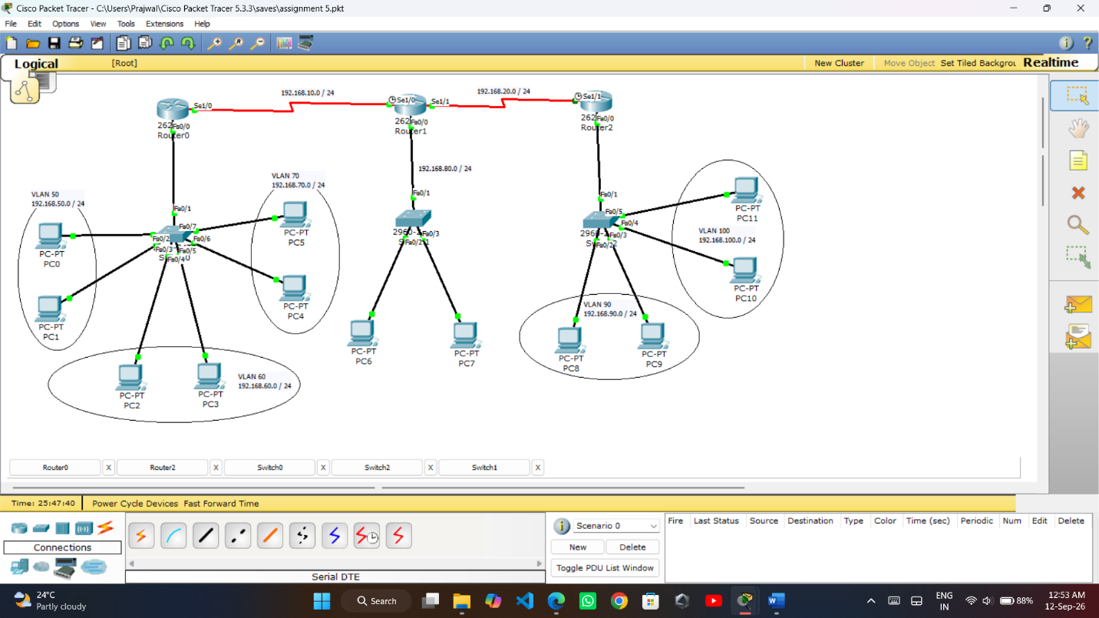

Switch S1 –
3 VLAN: - 50,60,70 having IP 192.168.50.0, 192.168.60.0, 192.168.70.0
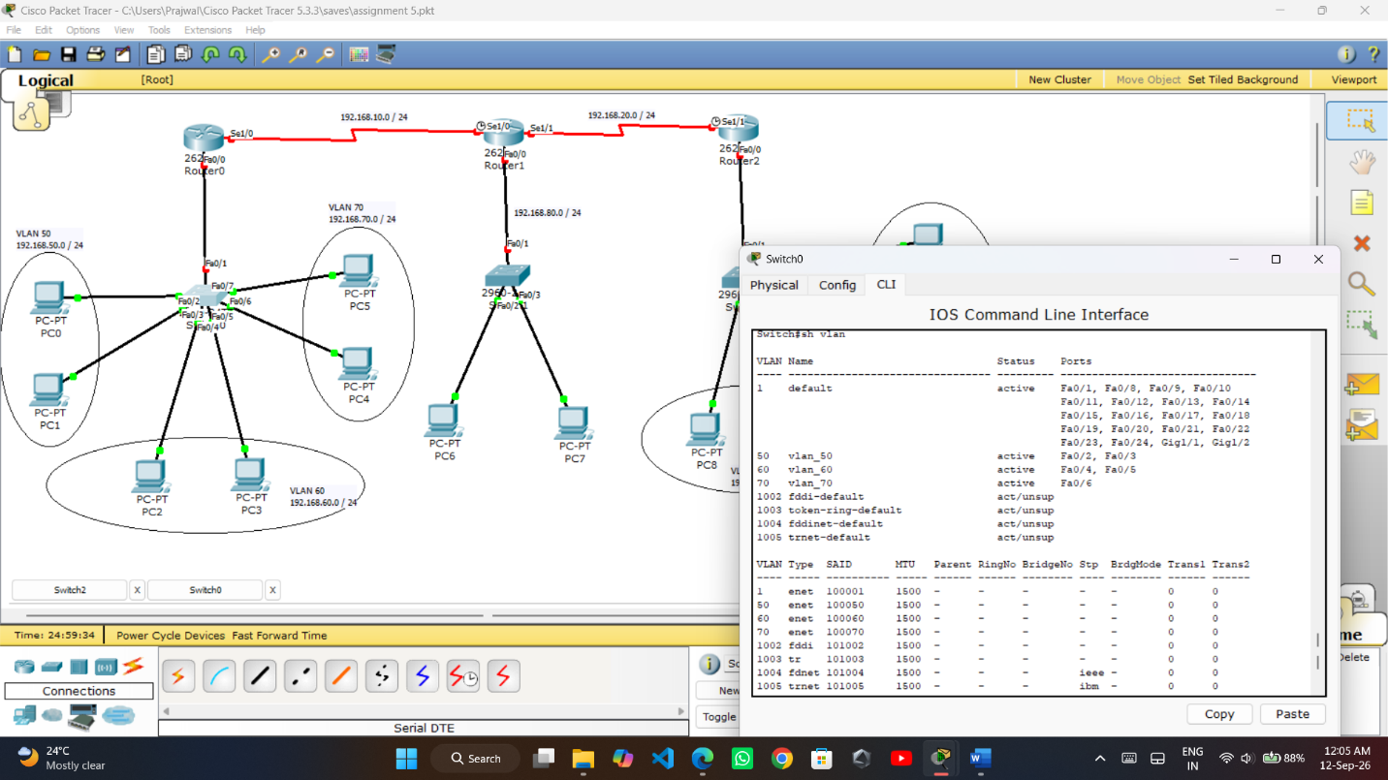

Switch S3 –
2 VLAN: - 90,100 having IP - 192.168.90.0, 192.168.100.0
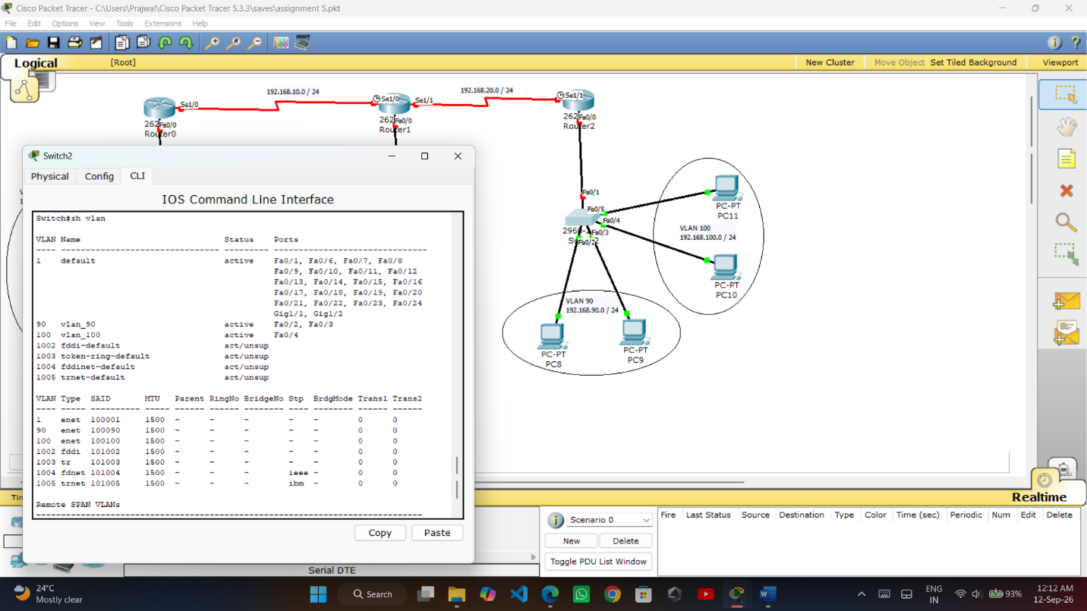

On Router 0
Wan link: - 192.168.10.0
LAN virtual links- 192.168.50.0 192.168.60.0 192.168.70.0
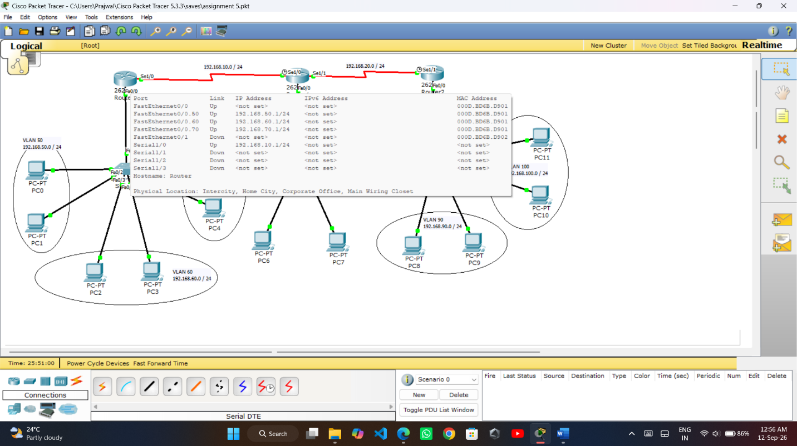
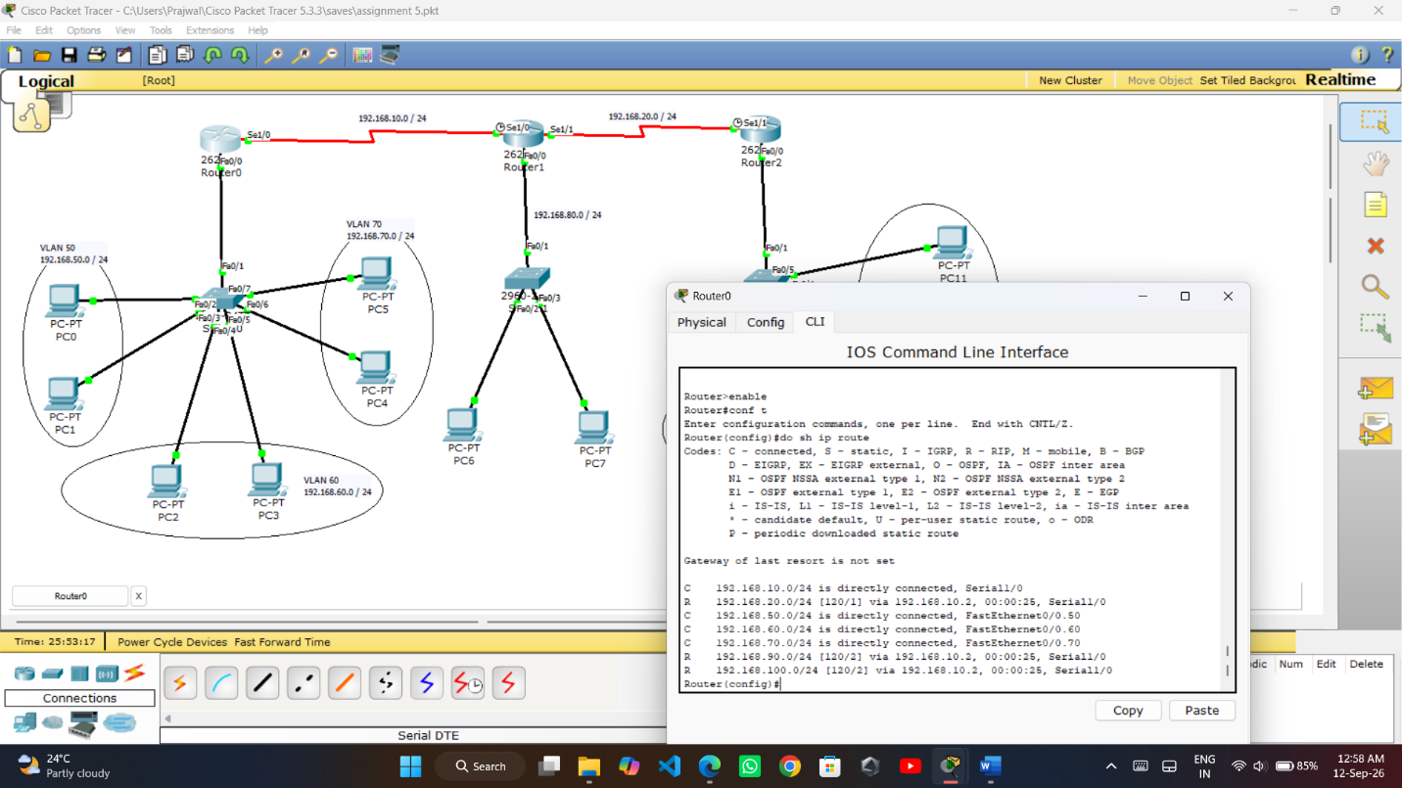

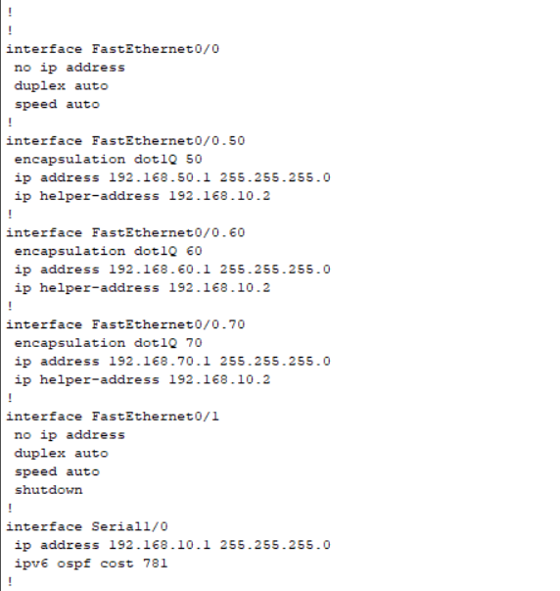

On Router 1 ( Central DHCP Server )
Wan link: - 192.168.10.0 C 192.168.20.0
LAN virtual links- 192.168.80.0
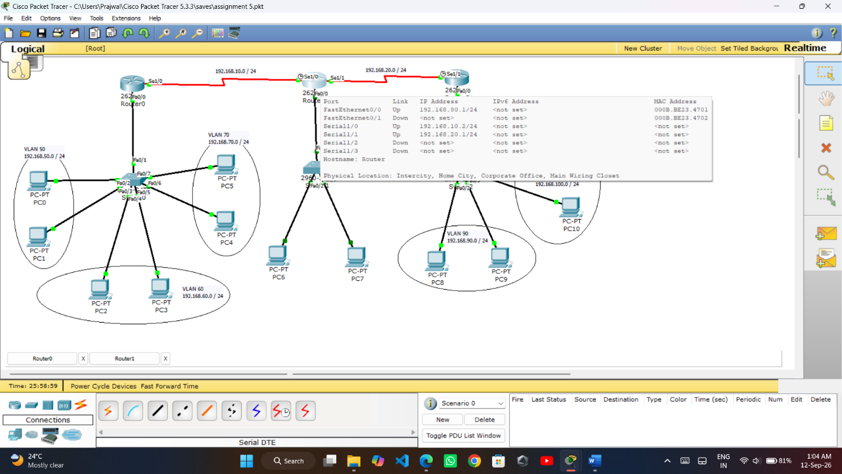

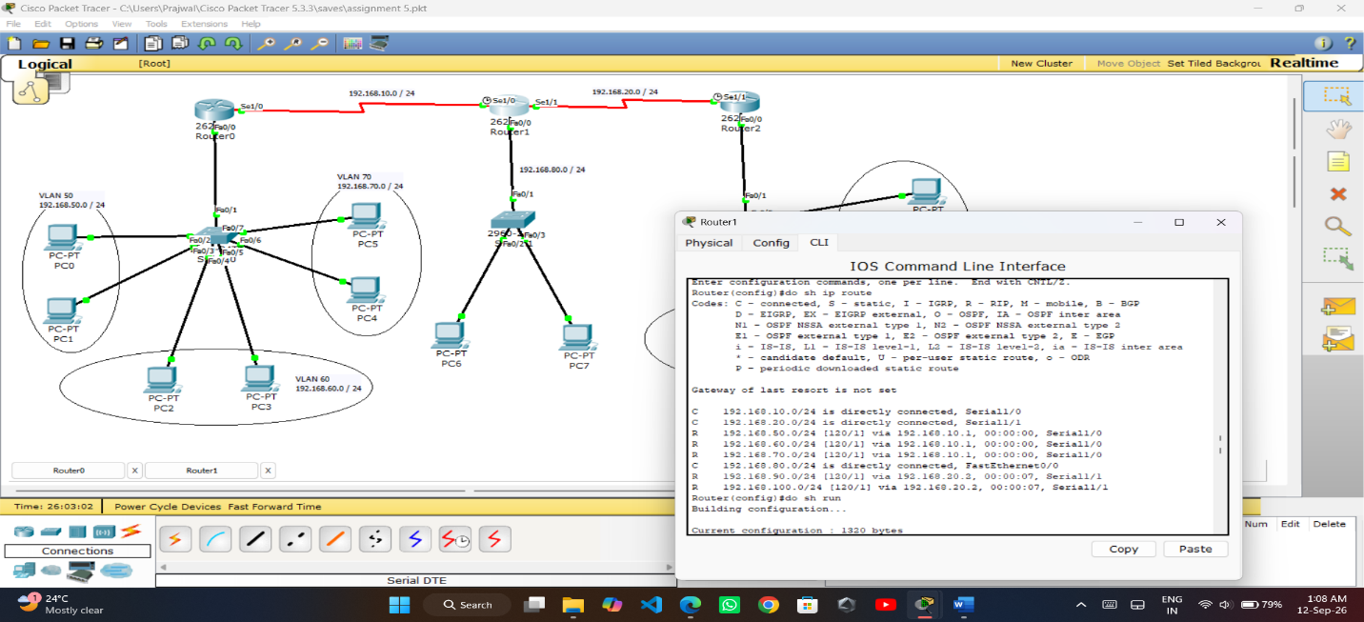
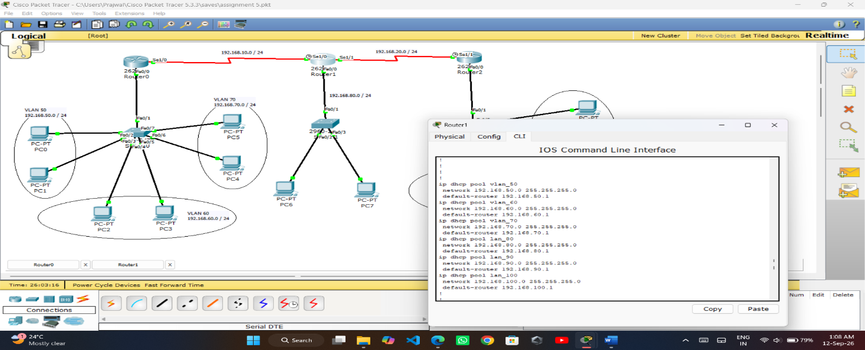
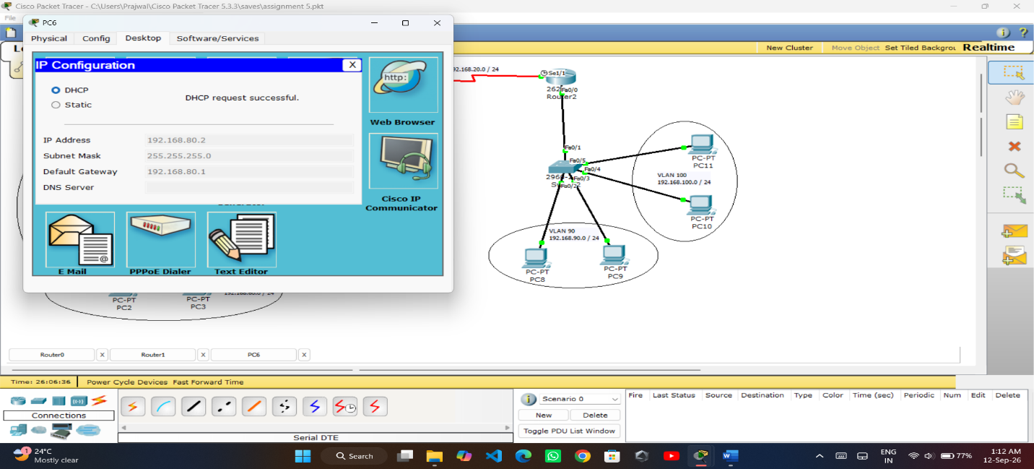
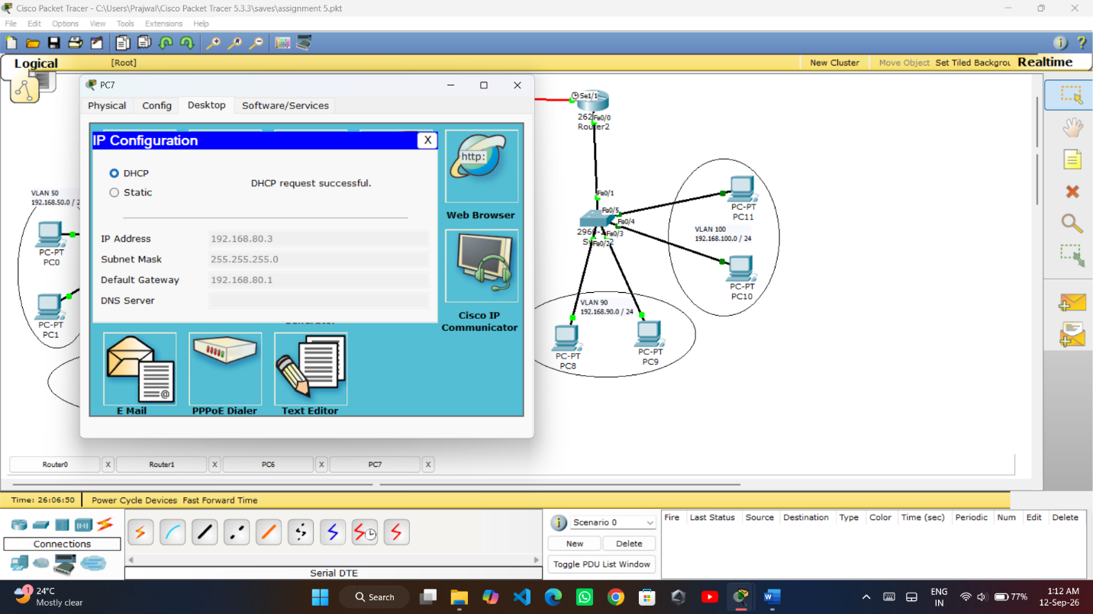
On Router 2
Wan link: - 192.168.20.0
LAN virtual links- 192.168.90.0 192.168.100.0
